**UML Design Models**

Rebecca Yorty

The University of Arizona Global Campus

CST499: Capstone for Computer Software Technology

Dr. Amjad Alkilani

May 09th, 2022

**Class Diagram:**

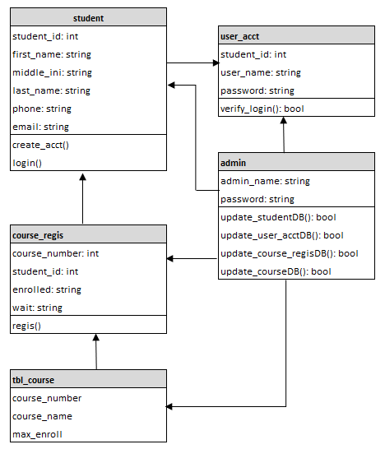

**Sequence Diagram:**

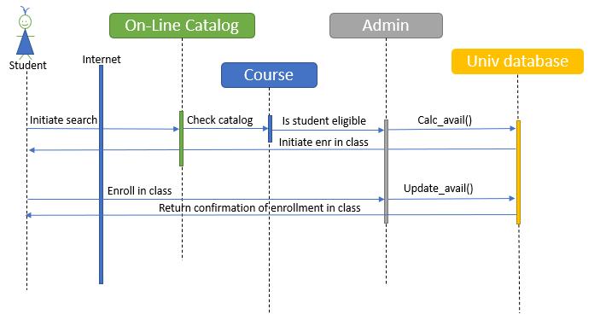

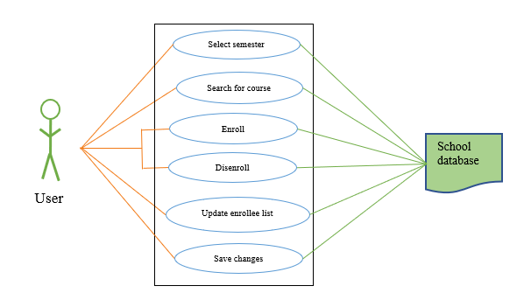**Use-Case**